**Assignment 2: Web-based Data Visualization using D3**

Jaeyoon Lee

Department of Computer Science and Engineering, Korea University

AAA633: Visual Computing

Prof. Won-Ki Jeong

December 11, 2022

1. **Table Visualization**The provided input data were loaded by using d3.csv() built-in parser. All scripts were written in ‘visualization.js’ file, and the web page is implemented by ‘index.html’ file. Since the table was too big, the area of table was limited in the width of 600px and the height of 500px. The output is as follows:  
   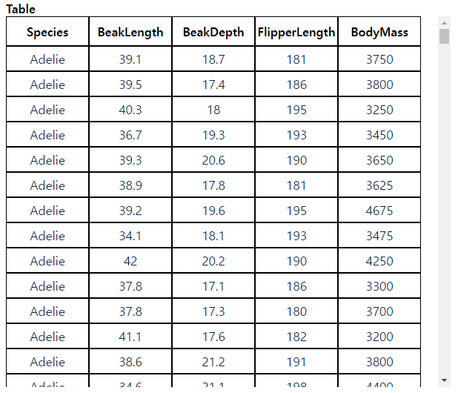  
   Source code reference: <https://keeper.tistory.com/13>
2. 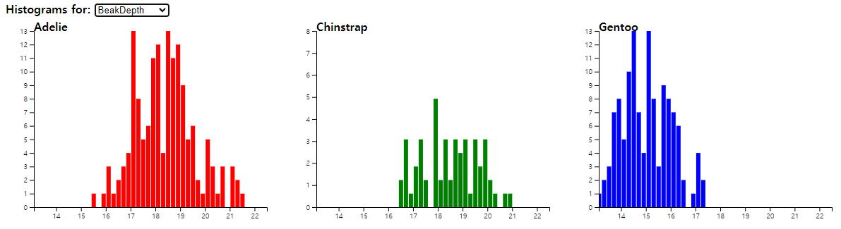**Histogram Plot**By selecting four attributes in a top-down menu, the number of each species were visualized in histogram. Adelie is represented as red, Chinstrap is green, and Gentoo is blue. The output is as follows:  
   Source code reference: <https://d3-graph-gallery.com/graph/histogram_basic.html>  
   <https://d3-graph-gallery.com/graph/line_select.html> (for top-down menu)
3. **Parallel Coordinate Plot**Parallel coordinate plot represents four different attributes, which are beak length, beak depth, flipper length, and body mass. Same as above, species were colored as red, green, and blue, which represent Adelie, Chinstrap, and Gentoo in same order. Each cluster of species is highlighted when the mouse is located on the lines. The output is as follows:  
   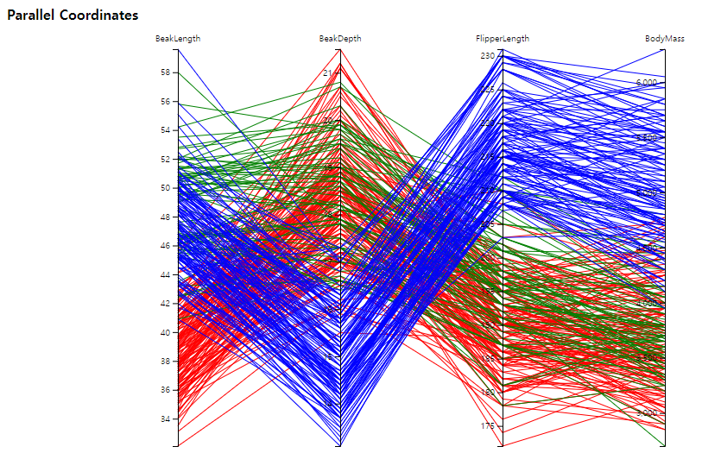  
   Source code reference: <https://d3-graph-gallery.com/graph/parallel_custom.html>
4. **Scatter Plot**By selecting each x and y axis attributes in top-down menus, each data is displayed as a point on a 2D plot with a corresponding color. Again, colors of species are same as above. The best combination of attributes that separates three penguin species was beak length and flipper length. The output is as follows:  
   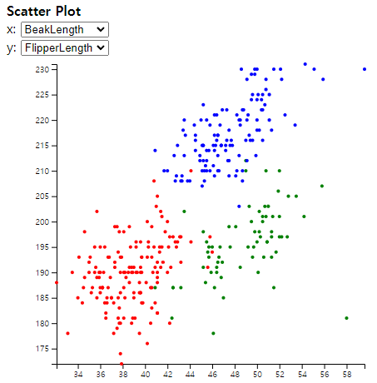  
   Source code reference: <https://d3-graph-gallery.com/graph/scatter_grouped.html>
5. **t-SNE Plot**To visualize 2D t-SNE embedding, ‘tsne.min.js’ script file was imported, which is an algorithm implemented in JavaScript. To calculate the output of t-SNE, raw data were parsed into nested array that only have numeric values of each penguin. After t-SNE is finished, the array contained t-SNE values was split into three arrays, which represent each species of penguins. User-parameters such as perplexity, learning rate, and metric were available to change specific values. However, it was hard to find the best t-SNE that separates three penguin species. The output is as follows:  
   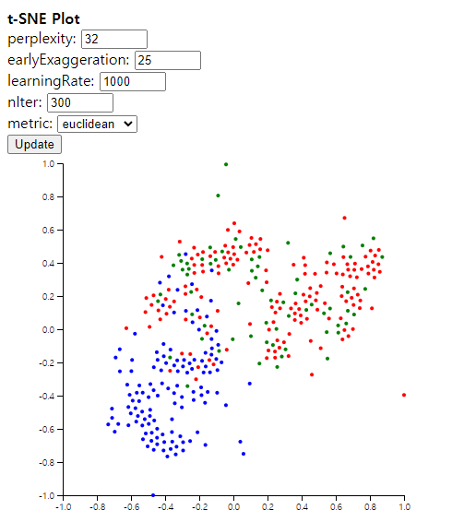  
   Source code reference: <https://github.com/scienceai/tsne-js/tree/master>